|  |
| --- |
| **Year 11 Specialist Mathematics**  Semester 2, August 2020  **Test 4: Trigonometric Functions and Identities**  **Calculator Free Weighting: 6%**  **[Australian Curriculum Reference Numbers: 2.1.1 - 2.1.9]** |

**Total Time: 50min Total Marks = $\frac{}{50}$**

**Student Name:**

**Teacher: ___________________________________**

**INSTRUCTIONS TO STUDENTS:**

* You **are not allowed** a calculator
* You are allowed 1 A4 page (1 side only) of notes
* A formula booklet will also be provided.

You are required to attempt ALL questions.

Write answers in the spaces provided beneath each question.

Marks are shown with the questions.

**Show all working** clearly, in sufficient detail to allow your answers to be checked readily and for marks to be answered for reasoning. Incorrect answers given without supporting reasoning cannot be allocated any marks. For any question or part question worth more than two marks, valid working or justification is required to receive full marks.

1. Determine the value of the pronumerals for the following graphs.

Image result for red tick no backgroundImage result for red tick no backgroundImage result for red tick no backgroundImage result for red tick no background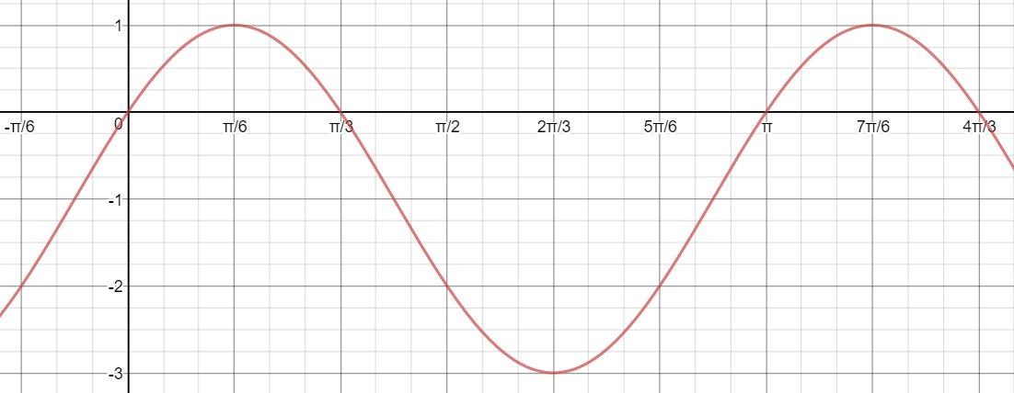

|  |
| --- |
|  |

Image result for red tick no backgroundImage result for red tick no background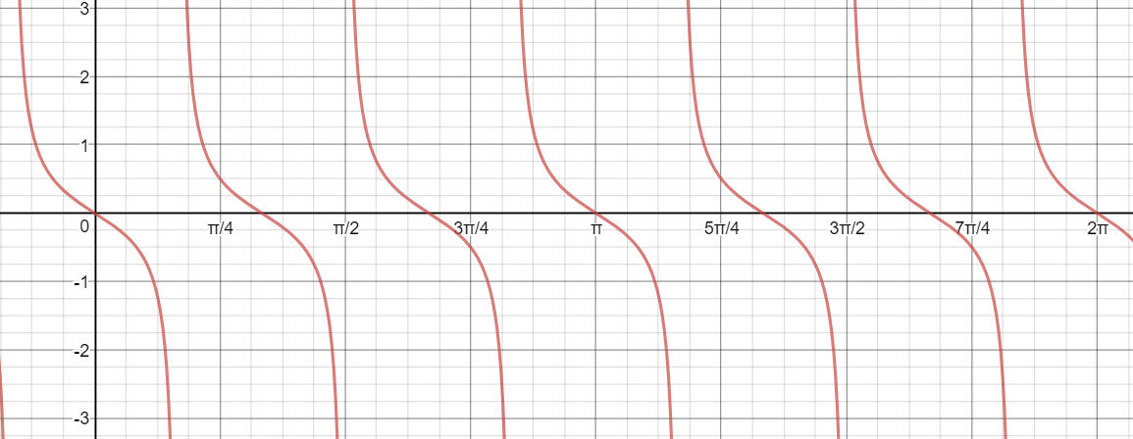

|  |
| --- |
|  |

Image result for red tick no backgroundImage result for red tick no background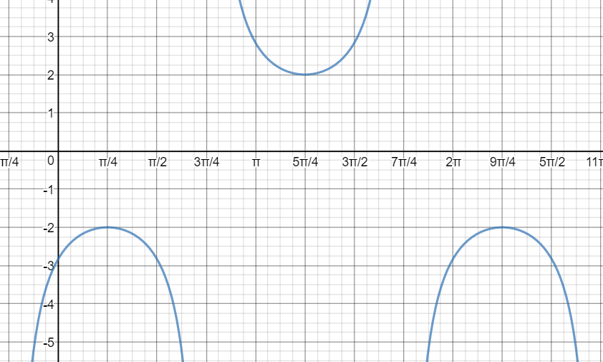

|  |
| --- |
|  |

[8 marks]

1. Image result for red tick no backgroundImage result for red tick no backgroundImage result for red tick no backgroundProve that .

|  |
| --- |
|  |
|  |
|  |
| Image result for red tick no background |
|  |
| Image result for red tick no background |
|  |
| Image result for red tick no backgroundImage result for red tick no backgroundQ.E.D |
|  |
|  |
|  |
|  |

[7 marks]

1. Image result for red tick no backgroundImage result for red tick no backgroundImage result for red tick no backgroundImage result for red tick no backgroundImage result for red tick no backgroundImage result for red tick no backgroundUse a double angle formula to determine the exact value of $\sin{\frac{9π}{8}}$. Express your answer with a rational denominator.

|  |
| --- |
| $Using\cos{2x}=1-2\sin^{2}{x}, with x=\frac{9π}{8}$ |
| $$\cos{\frac{9π}{4}}=1-2\sin^{2}{\frac{9π}{8}} ⟹ \frac{\sqrt{2}}{2}=1-2\sin^{2}{\frac{9π}{8}}$$ |
| $$\frac{\sqrt{2}-2}{2}=-2\sin^{2}{\frac{9π}{8}}$$ |
| $$\frac{2-\sqrt{2}}{4}=\sin^{2}{\frac{9π}{8}}$$ |
| $$\sin{\frac{9π}{8}}=±\frac{\sqrt{2-\sqrt{2}}}{2}$$ |
| $$But,\frac{9π}{8}is in the 3rd Quadrant, making\sin{negative} ∴\sin{\frac{9π}{8}}=-\frac{\sqrt{2-\sqrt{2}}}{2}$$ |
|  |
|  |

[6 marks]

1. Image result for red tick no backgroundImage result for red tick no backgroundSolve the following trigonometric equations:

|  |
| --- |
|  |
|  |
| Image result for red tick no backgroundImage result for red tick no backgroundImage result for red tick no backgroundImage result for red tick no background |
|  |
|  |
|  |
| ***Deduct 1 mark for each missing or incorrect solution *** |
|  |
|  |
|  |
| Image result for red tick no backgroundImage result for red tick no backgroundImage result for red tick no backgroundImage result for red tick no backgroundImage result for red tick no background |



|  |
| --- |
|  |
|  |
|  |
|  |
|  |
| ***Deduct 1 mark for each missing or incorrect solution *** |
| *** Various solutions – mark accordingly *** |
|  |
|  |
|  |

**[6,5 = 11 Marks]**

1. Prove the identity:

|  |
| --- |
| Image result for red tick no backgroundImage result for red tick no backgroundImage result for red tick no backgroundImage result for red tick no backgroundImage result for red tick no backgroundLHS: |
|  |
|  |
|  |
|  |
|  |
|  |
| QED |
| *** Various answers – mark accordingly *** |

[5 marks]

1. Image result for red tick no backgroundSketch for .

|  |
| --- |
| Image result for red tick no backgroundImage result for red tick no backgroundPut into auxiliary angle form: |
|  |
|  |
| Image result for red tick no backgroundHence, |
|  |

Image result for red tick no backgroundImage result for red tick no background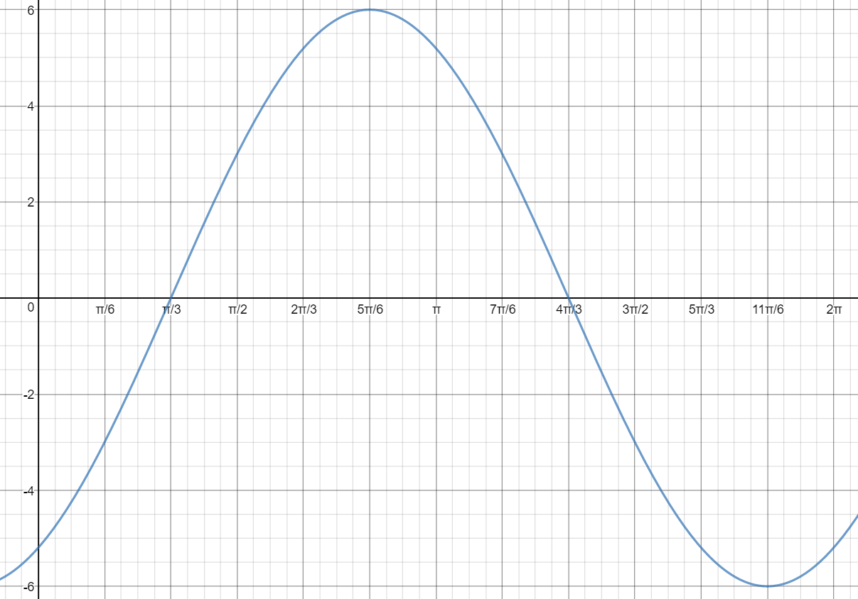

[6 marks]

1. Image result for red tick no backgroundImage result for red tick no backgroundImage result for red tick no backgroundExpress the value of $\sin{75°}\cos{15°}$ as a single fraction.

|  |
| --- |
| $$\sin{75°}\cos{15°}=\frac{1}{2}[\sin{90°}+\sin{60°}]$$ |
| $$=\frac{1}{2}(1+\frac{\sqrt{3}}{2})$$ |
| $$=\frac{1}{2}+\frac{\sqrt{3}}{4}$$ |
| $$=\frac{2+\sqrt{3}}{4}$$ |
|  |
|  |
|  |

[3 marks]

1. Sketch , for

Image result for red tick no backgroundImage result for red tick no backgroundImage result for red tick no backgroundImage result for red tick no background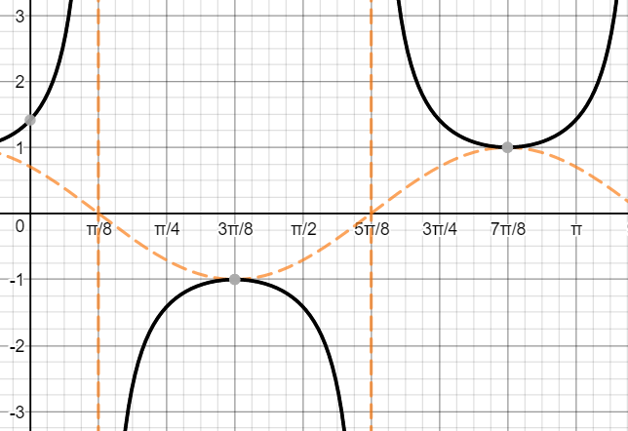

*** Deduct a mark for no asymptotes shown and one for going beyond domain ***

[4 marks]

*** End of Test ***

***Extra space for working out***

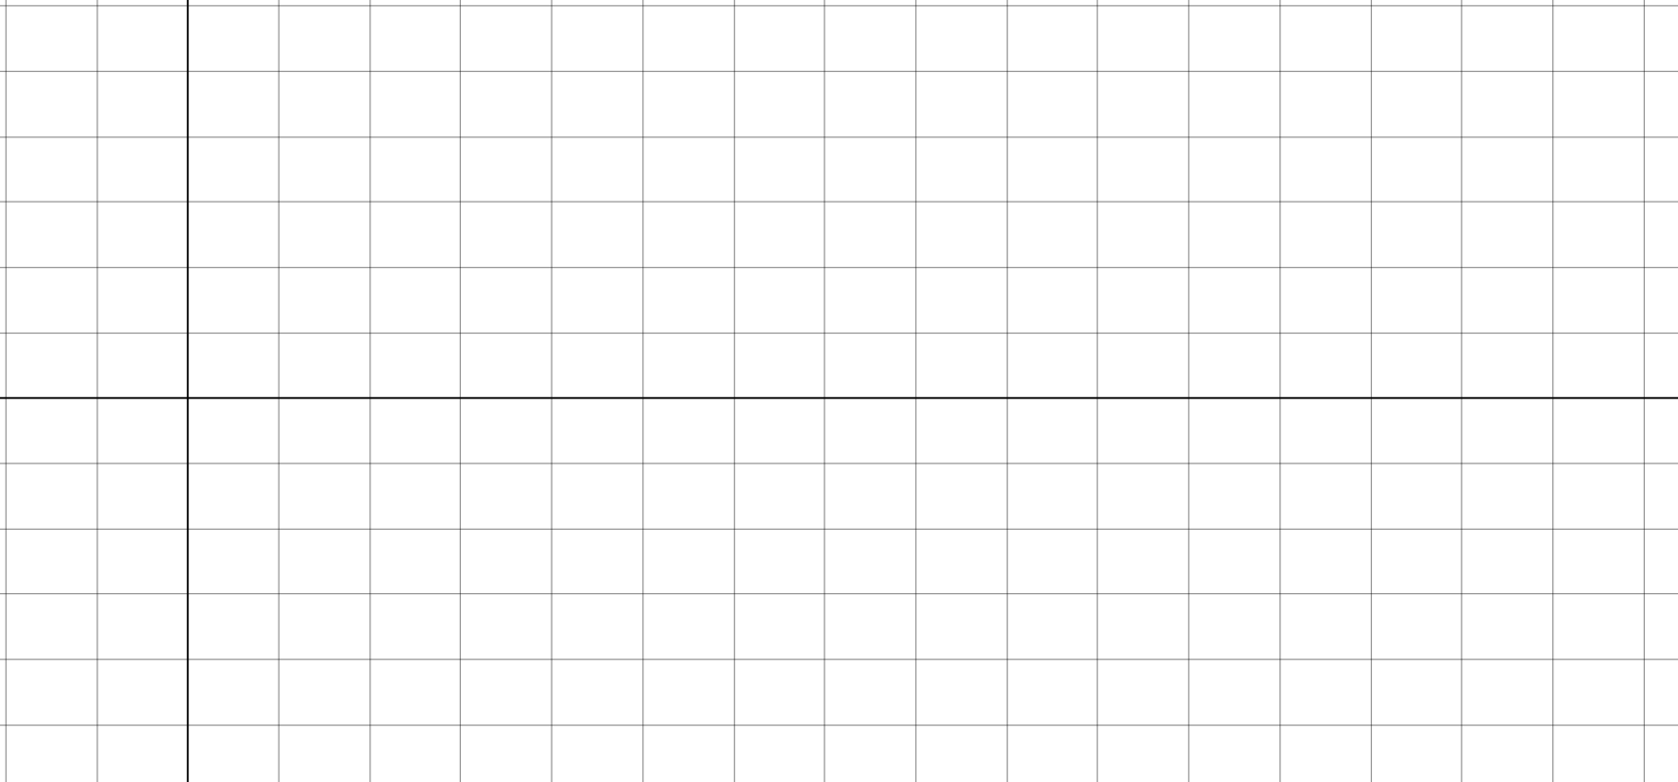

|  |
| --- |
|  |
|  |
|  |
|  |
|  |
|  |
|  |
|  |
|  |
|  |
|  |
|  |
|  |
|  |
|  |
|  |
|  |
|  |

***Extra space for working out***



  
  
  
  
  
  
  
  
  
  
  
  
  
  
  